**Experiment 7**

**Aim**: To create a State diagram for the project Object Detection Solutions

**Requirements:**

Hardware:

* Intel 7th Gen CPU
* Graphics Card
* Storage – Hard Disk

Software:

* OS: Ubuntu, Windows, MacOS
* Umbrello UML Modeler

**Theory:**

A State diagram describes a state machine. State machine can be defined as a machine which defines different states of an object and these states are controlled by external or internal events.

State diagram is one of the five UML diagrams used to model the dynamic nature of a system. They define different states of an object during its lifetime and these states are changed by events. State diagrams are useful to model reactive systems. Reactive systems can be defined as a system that responds to external or internal events.

State diagram describes the flow of control from one state to another state. States are defined as a condition in which an object exists and it changes when some event is triggered. The most important purpose of State diagram is to model the lifetime of an object from creation to termination.

State diagrams are also used for forward and reverse engineering of a system. However, the main purpose is to model the reactive system.

Following are the main purposes of using State diagrams −

1. To model the dynamic aspect of a system.
2. To model the life time of a reactive system.
3. To describe different states of an object during its life time.
4. Define a state machine to model the states of an object.

State diagrams are used to model the states and also the events operating on the system. When implementing a system, it is very important to clarify different states of an object during its life time and State diagrams are used for this purpose. When these states and events are identified, they are used to model it and these models are used during the implementation of the system.

If we look into the practical implementation of State diagram, then it is mainly used to analyze the object states influenced by events. This analysis is helpful to understand the system behavior during its execution.

It’s a behavioral diagram and it represents the behavior using finite state transitions. State diagrams are also referred to as State machines and State-chart Diagrams. These terms are often used

interchangeably. So simply, a state diagram is used to model the dynamic behavior of a class in response to time and changing external stimuli. We can say that each and every class has a state but we don’t model every class using State diagrams. We prefer to model the states with three or more states.

State diagram is used to describe the states of different objects in its life cycle. Emphasis is placed on the state changes upon some internal or external events. These states of objects are important to analyze and implement them accurately.

State diagrams are very important for describing the states. States can be identified as the condition of objects when a particular event occurs.

Before drawing a State diagram, we should clarify the following points −

* Identify the important objects to be analyzed.
* Identify the states.
* Identify the events.

Following is an example of a State diagram where the state of Order object is analyzed

The first state is an idle state from where the process starts. The next states are arrived for events like send request, confirm request, and dispatch order. These events are responsible for the state changes of order object.

During the life cycle of an object (here order object) it goes through the following states and there may be some abnormal exits. This abnormal exit may occur due to some problem in the system. When the entire life cycle is complete, it is considered as a complete transaction.

## Basic State Chart Diagram Symbols and Notations

**States**  
States represent situations during the life of an object. You can easily illustrate a state by using a rectangle with rounded corners.

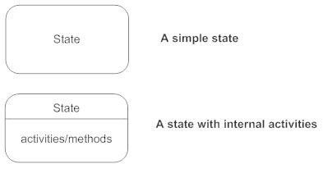

**Transition**  
A solid arrow represents the path between different states of an object. Label the transition with the event that triggered it and the action that results from it. A state can have a transition that points back to itself.

Transitions - State diagram

**Initial State**  
A filled circle followed by an arrow represents the object's initial state.

Inititial state - State diagram

**Final State**  
An arrow pointing to a filled circle nested inside another circle represents the object's final state.

Final state - State diagram

**Synchronization and Splitting of Control**  
A short heavy bar with two transitions entering it represents a synchronization of control. The first bar is often called a fork where a single transition splits into concurrent multiple transitions. The second bar is called a join, where the concurrent transitions reduce back to one.

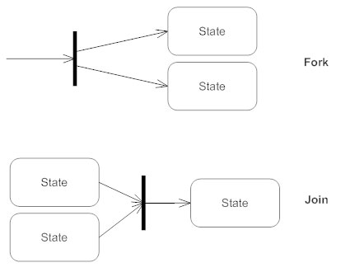

**State Diagrams for the Given Projects: Object Detection Solutions**

State Diagram 1:

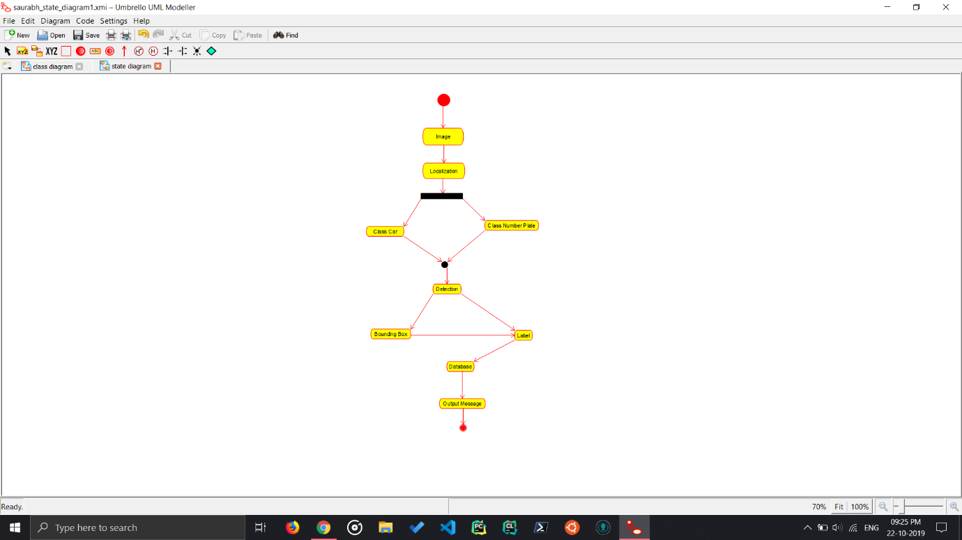

Car Parking Detection

State Diagram for Car Parking Detection, this state diagram shows the YOLO approach to object Detection where Detection is done in Real Time. This is YOLO methodology which is the fastest object detection. It is a simple and a powerful approach to Object Detection.

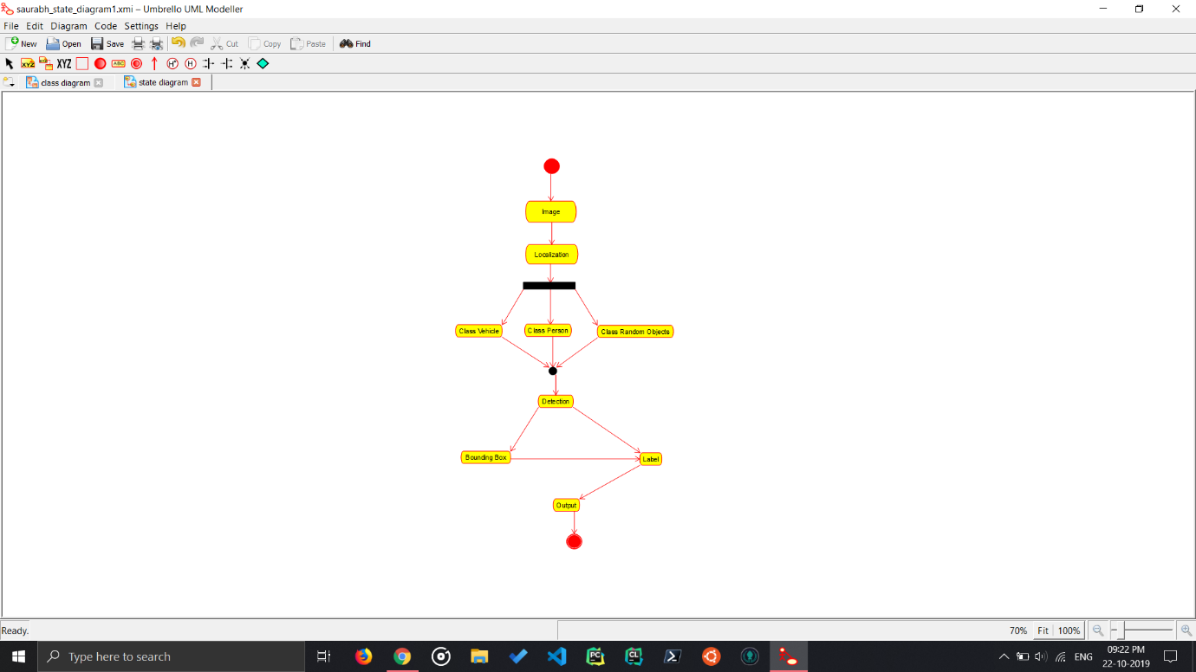State Diagram 2:

Object Detection Methodology

Data Flow Diagram for Object Detection system, it identifies the object, checks the database for the Label and then gives the user the output. This is YOLO methodology which is the fastest object detection. It is a simple and a powerful approach to Object Detection.

**Conclusion:**

The State Diagram for the project Object Detection Solution has been made.